1. Introduction
For this final project for Human Computer Interaction, our group designed a prototype of a ubiquitous computing environment by integrating iCatch with sound input and output devices on laptop. To be creative, our product allows users to communicate with computer by sitting position and spoken language.

Instead of using keyboard and mouse as input, user can talk to computer by nature spoken language and sitting position in our designed environment, and computer will response to users by English, Mandarin and Cantonese and adjust the volume of music player according to users’ sitting position. To actualize this environment, a sensor of iCatch is embedded on the chair which will provide computer information about the distance between chair and human body. A prompt response to the user’s position from the system is provided via the volume of the music and also change of LED light which enhances the clearance and effectiveness of the system’s response.

There will be much fun when our system is applied in multi-users environment. Different chairs are represented with different music instruments; there will be different combinations of music tracks when different seats are occupied. Users can experience the feeling of playing music in a band or orchestra.

In this report, motivation of the system design, detailed description on the system development and functions, user tests results and discussion, and evaluation of system will be presented.

2. Motivation
Computer, which brings a lot of modern entertainment products, could also be integrated with classical entertainments. Many people enjoy listening to music when they would like to escape from their busy daily life; playing music by our own will be even more fun. However, that requires techniques and practices. How can we make more people get the chance to be a “music player”? Music changes when the position and power of players’ figure changes, our system does not allow users to change the tone and pace to ensure the output music is enjoyable, but allow different combination of sound from music instruments and change of volume to let user experience the change of music when they change their positions. We also designed the nature language communication to free the users from keyboard and screen and make necessary instruction.

This system can be used in various occasions in daily life. Two examples are discussed here. Education institutions and families can use this system in music appraisal education and stimulate the interests of children to music. Instead of just seating and listening to the music, children can play around with different chairs. This education model could make the classic music less boring to children and even develop their interest in it. Café and restaurant could use our system, especially music themed business, so that the background music of the café can be change by guests. The more guests, the more complete the music piece is. Our system could also save labor cost by providing welcome message via the system when it is detected that a guest is entering the café or restaurant.

When using our system, a single user will hear the welcome message and instruction from the system, may try to change the volume by moving their body and seat on different chairs to hear the different sound of instrument. If there is more than one user, users can by to combine music tracks by sitting on different chairs. In our prototype system, there are three tracks embedded. So that the max people for playing will be three. The system will be better to developed with some support from music professionals to design how to separate the whole music into a certain number of music tracks.

3. Description
3.1 Hardware Specification
Our device is including the following stuffs.
Personal Computer x 1
Personal computer is connecting all Zigbee connector. It will runs program once receive data or signal from Zigbee.

Zigbee connector x 3
Zigbee connector are connecting to personal computer for short-range wireless data transfer with iCatch.

Power supply set x 3
It will put in each chair for provides power to light sensor and LED matrix module.

Light sensor x 3
Light sensor is putting on the chair to detect light. When someone sitting on the chair, the sensor cannot detect light, then the iCatch will call the program and the instrument music sound track will comes out.

LED matrix module x 3
LED matrix module is putting near the chair for display the volume signal of that instrument music sound.

3.2 Device Design
Our device design is as follow:

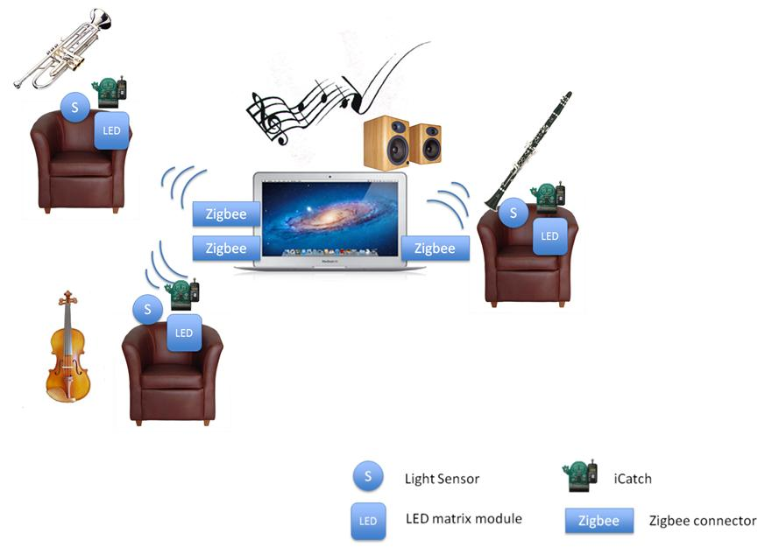

3.3 Program Structure
We use Java and i*CATch Java library to develop program as Java is fast, secure and reliable. There are total _____ classes for our device, the details are as follows:

Java class name | Function

3.3.1 State Transition Networks (STNs)

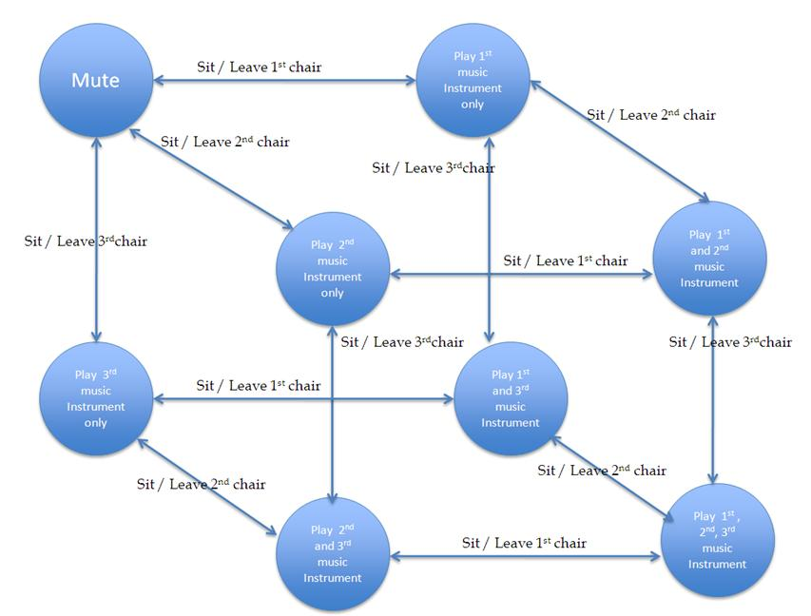

2. User Test

Case 1
Preparation | Empty all chair
User Test | Steps | Expected feedback
 | 1. User stand near the chair | Voice welcome message and brief introduction
 | 2. User sit on 1st chair | 1st music instrument sound track will be play.
 | 3. User leave 1st chair | 1st music instrument und track will be stopso

Case 2
Preparation | 1st chair occupied and 1st music instrument is playing
User Test | Steps | Expected feedback
 | 1. User sit on 2nd chair | 1st and 2nd music instrument sound track will be play together.
 | 2. User sit on 3rd chair | 1st, 2nd and 3rd music instrument sound track will be play together.
 | 3. User leave 1st chair | 1st music instrument sound track will be stop; 2nd and 3rd music instrument sound track will keep playing
 | 4. User leave 2nd chair | 2nd music instrument sound track will be stop; 3rd music instrument sound track will keep playing
 | 5. User leave 3rd chair | 3rd music instrument sound track will be stop.

